

**DESIGN DOCUMENT**

**Website Development**

Created By: Client:EminThaqi

Ignas Apšega

Lokesh Agnihotri

# **INTRODUCTION**

We intend to create an e-Commerce website for corporate offices, where visitor can see all the publicly listed products. The website will allow them to view products, it’s specifications like size, colour, configuration etc. The registered users will also be able to view all the products and purchase them directly or after adding it to their cart.

The advantage of this website is that it’s really simple and hence it is easy to use by anyone.

# **Target AuDIENCE**

The website targets a sector of corporate offices and anyone else that want to order the listed products. Age group is not a criteria to use the website . The products listed on the website are limited to a certain category ensuring that the attracted audience is not too broad or narrow.

The website currently is only in global English Language and hence it can be used by anyone across the world. Also the website will be designed in a manner that it is easily accessible through mobile or computers.

# Scope of the Project

Our website has a huge scope to act as a fully functional website, also since it has a very simple design to understand, it can be easily modified as per the need of the client so that it can reach the desired audience.

# Site Map

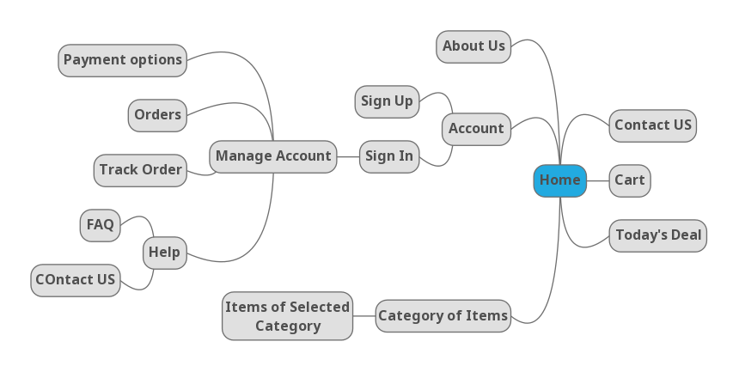

# WireFrames

**HOME PAGE:**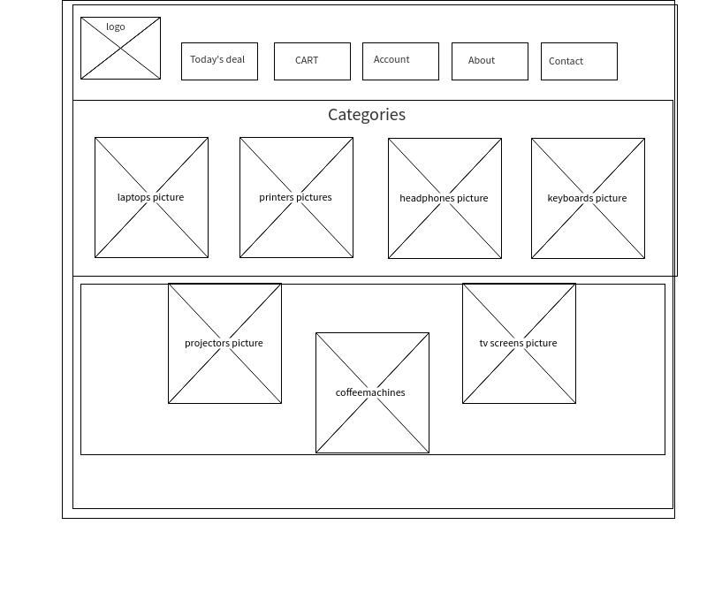

**ACCOUNT**

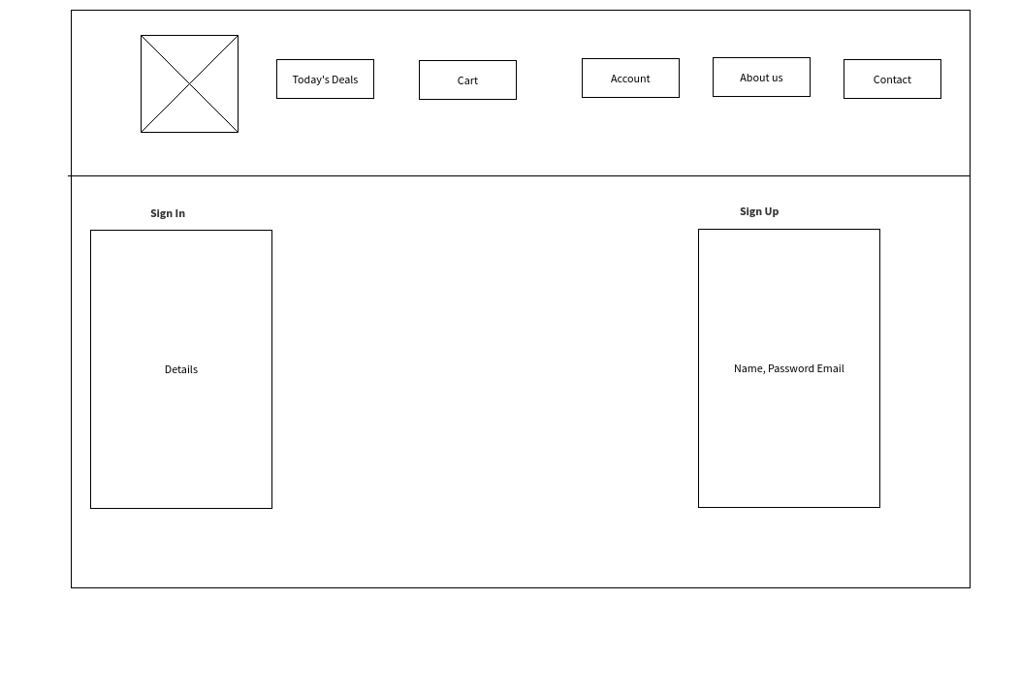

**ABOUT US:**

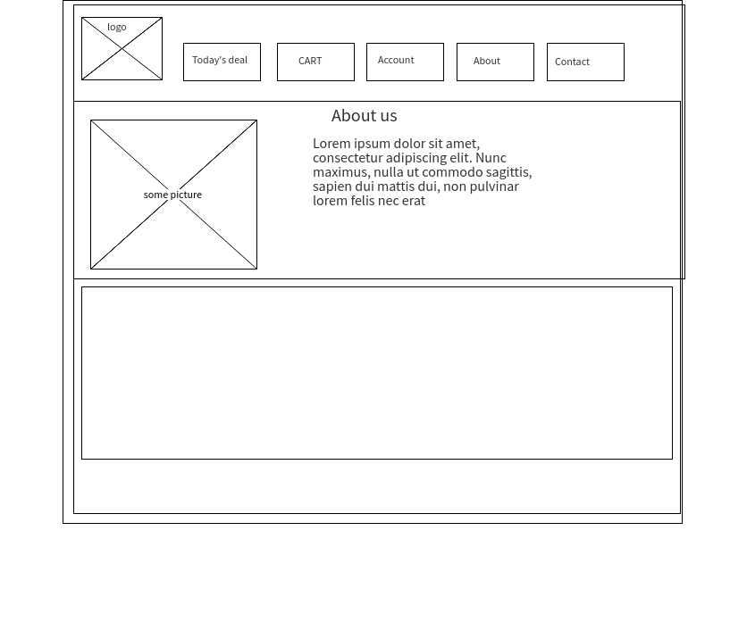

**FAQ:**

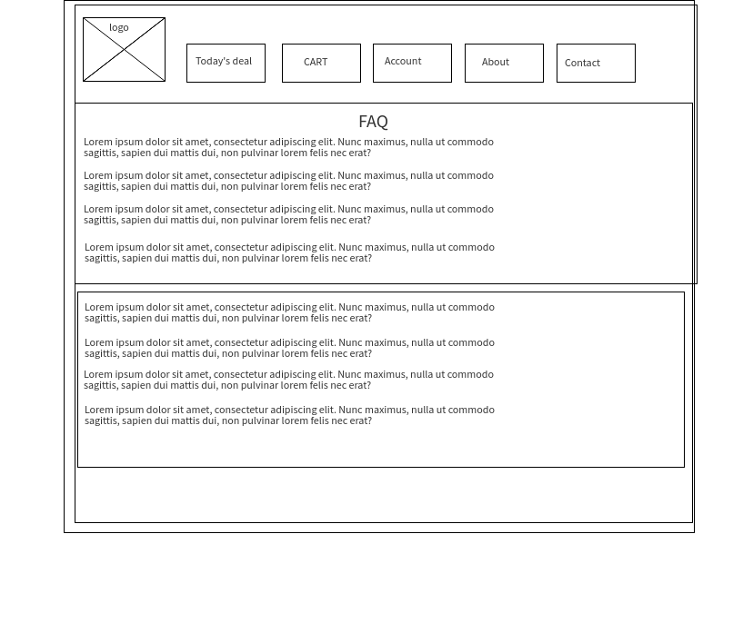

**PRODUCTS:**

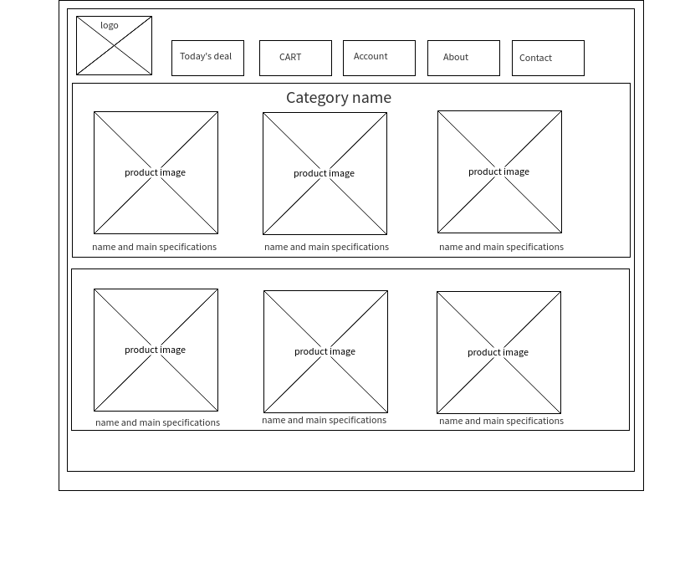

**Product PAGE**

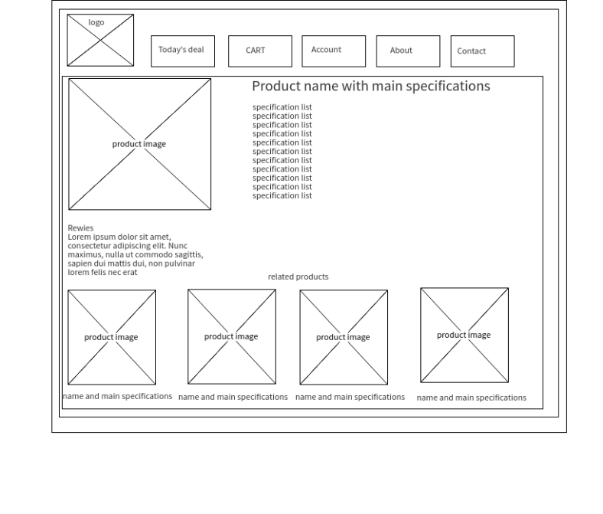

# Visual Design

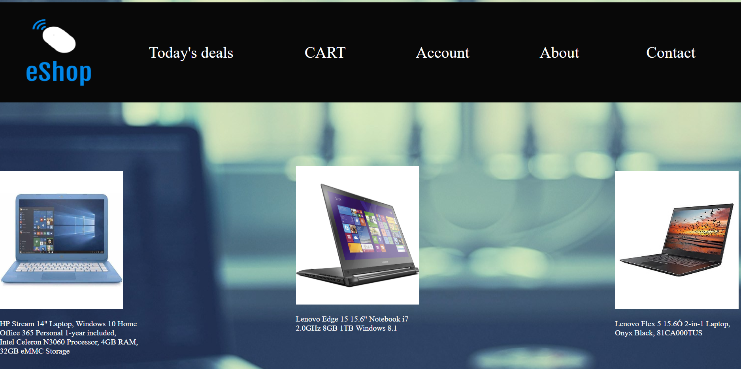

# TECHNOLOGY USED

* HTML
* CSS
* JAVA SCRIPT
* PHP